**CS624 Full-Stack Development Mobile App**

**PE02 – Core Components**

Developed by Sam Chung on February 25, 2022

School of Technology & Computing (STC)

City University of Seattle (CityU)

**Before You Start**

* You already created a private GitHub repository for all your programming exercises, “cs624-pe-your_first_name.”
* You allowed your instructor and the Teaching Assistant to access your GitHub repository for programming assignments.
* The GitHub Codespaces may bill your account according to your usage. Check the price at <https://docs.github.com/en/billing/managing-billing-for-github-codespaces/about-billing-for-github-codespaces>.
* Some steps are not explained in the assignment**.**If you are not sure what to do:
  + Consult the resources listed in your course.
  + If you need help solving the problem after a few tries (~15 minutes), ask a TA for help.

**Learning Outcomes**

Students will be able to:

* Create a React Native mobile app using core components – View, Text, ScrollView, Image, TextInput, and StyleSheet.

**Problem**

Write a “CoreComponents” mobile app that will display MSCS courses with the following constraints:

* User Requirements
  + You can find the “icon.png” under the “./assets” directory.
  + You can enter your favorite course.
  + You display the 8 core, 2 depth of study, and 1 capstone course.
  + You can access the CityU’s catalog at <https://cityu.smartcatalogiq.com/2022-2023/ay-2022-2023-catalog/>.
* System Requirements
  + You must use an arrow function for the functional component.
  + You must use the core components at least once – View, Text, ScrollView, Image, TextInput, and StyleSheet.
  + Your screen is scrollable.
  + By using an internal style, the screen shows some styles.

For example, the following screen shows the outcomes.

**Submission**

1. If you already created a GitHub repository for your programming exercises, “cs624-pe-your_first_name,” create a directory for programming exercise 2, “PE02-CoreComponents.” For example, the screen below shows that the following seven directories were created for all programming exercises.

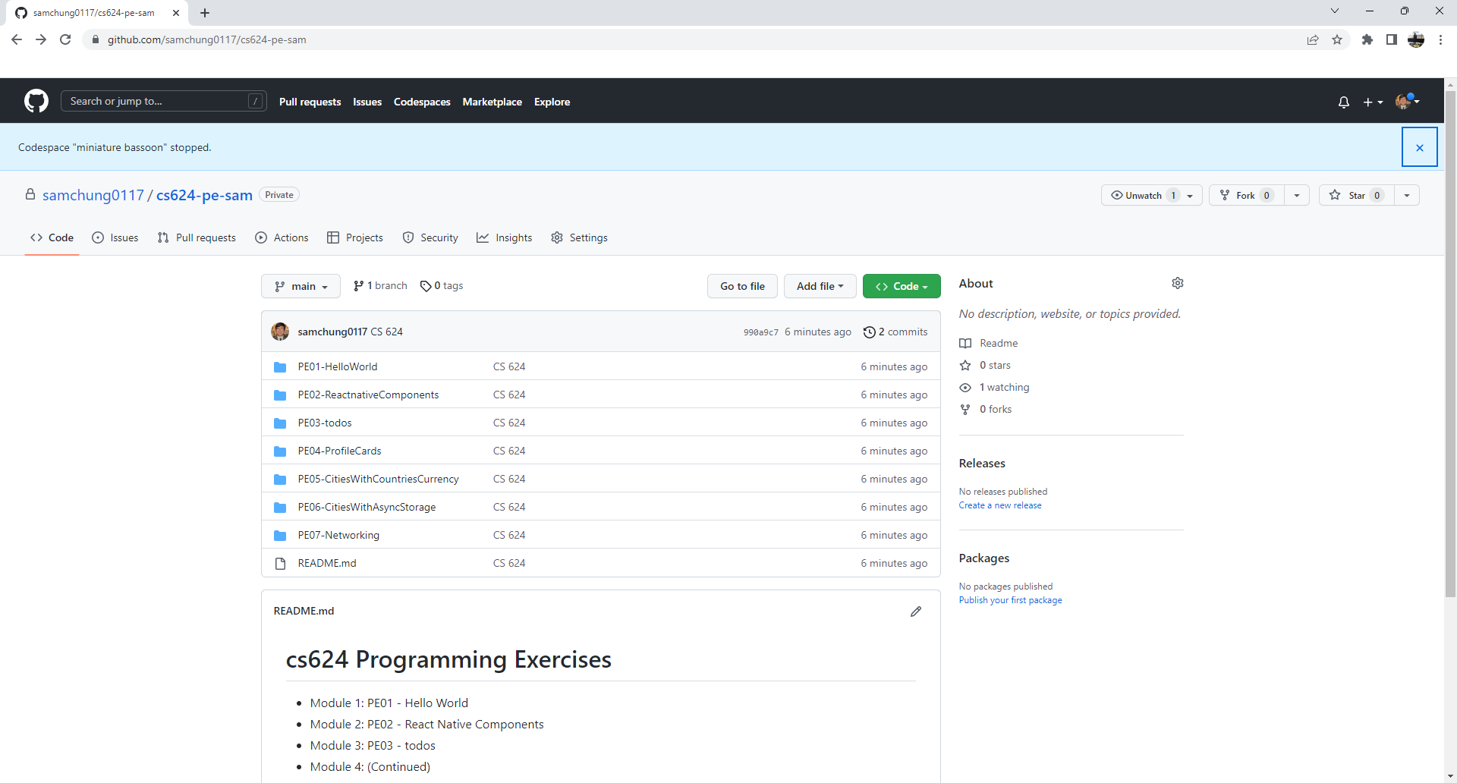

1. Finish your programming exercise under the PE02 directory.
2. Write a 150-word analysis report to explain how the program works in [README.md](https://www.markdownguide.org/basic-syntax/) regarding the [input-process-output model](https://press.rebus.community/programmingfundamentals/chapter/input-process-output-model/). The README.md has three level-1 headings – Input, Process, and Output.
3. Submit the link of your GitHub repository to your course shell through your assignment submission.